Performance Analysis Report
Vehicle Analytics Platform — Benchmark Session
This report documents a live benchmark of the detection + tracking pipeline (YOLOv8n + ByteTrack, CPU inference), captured with the platform's built-in performance logger. The session ran for 42.5 seconds across 566 logged frames and covered two different video sources loaded back-to-back within the same run — a lighter scene (few vehicles) followed by a denser scene (many vehicles) after the source was switched at the 23.24s mark. Both segments are reported separately below, since scene density materially changes several of the numbers.
Headline Results
Metric | Light scene | Dense scene | Full session
Avg FPS | 23.59 | 17.05 | 20.51

- Inference (YOLOv8n) averaged 41.6 ms/frame and stayed essentially flat across both scenes (40.16 ms light vs. 43.2 ms dense) — the model cost does not scale with object count.
- Tracking (ByteTrack) is cheap: 0.58–1.45 ms/frame even as active objects grew from ~4 to ~18.
- Overhead (drawing/encoding/IO) is what scales with scene density — 1.69 ms light vs. 14.22 ms dense, an ~8x increase — and is the main reason FPS drops in busy scenes.
- CPU usage sat around 203% throughout, i.e. roughly two cores fully occupied — consistent with CPU-only inference.
- Memory grew from 538.1 MB to 824.6 MB over the session (+286 MB, +53%) — flagged below as worth a longer-run check.

Throughput Over Time
FPS tracks scene density closely: it holds in the low-to-mid 20s during the light first segment, then settles around 17 fps once the denser second source loads, with brief dips as low as 8.6 fps during the busiest moments.
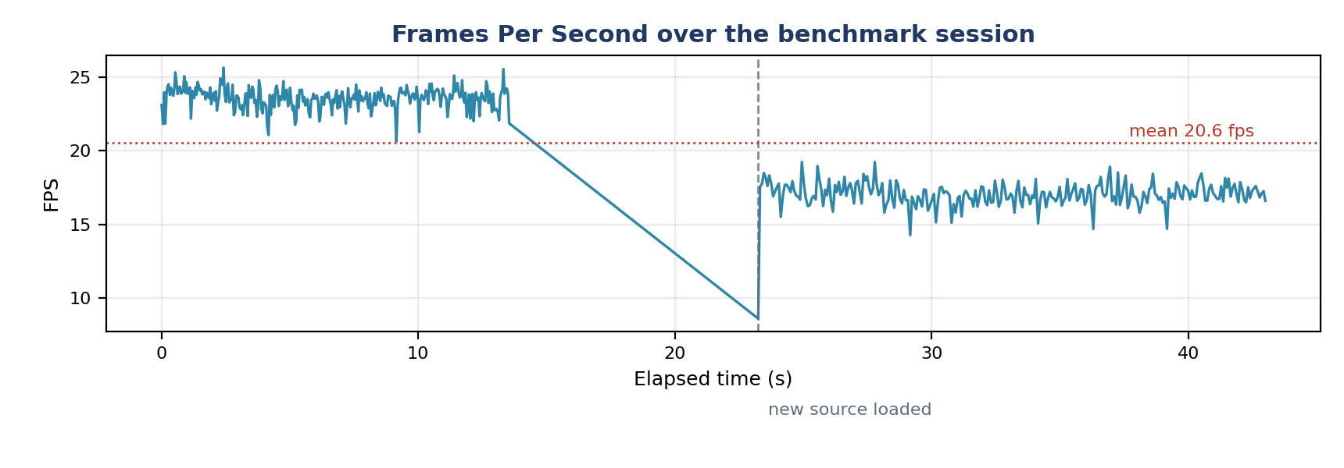
Figure 1: FPS over the full benchmark session. Dashed line marks the source switch.
Resource Usage Over Time
CPU usage is stable around 190–214% (roughly two cores) for almost the entire run. Memory rises in two visible steps — once during the light segment's warmup, and again sharply after the source switch — rather than climbing gradually, which points to per-source buffer allocation (e.g. trajectory history, frame buffers) rather than a slow per-frame leak.
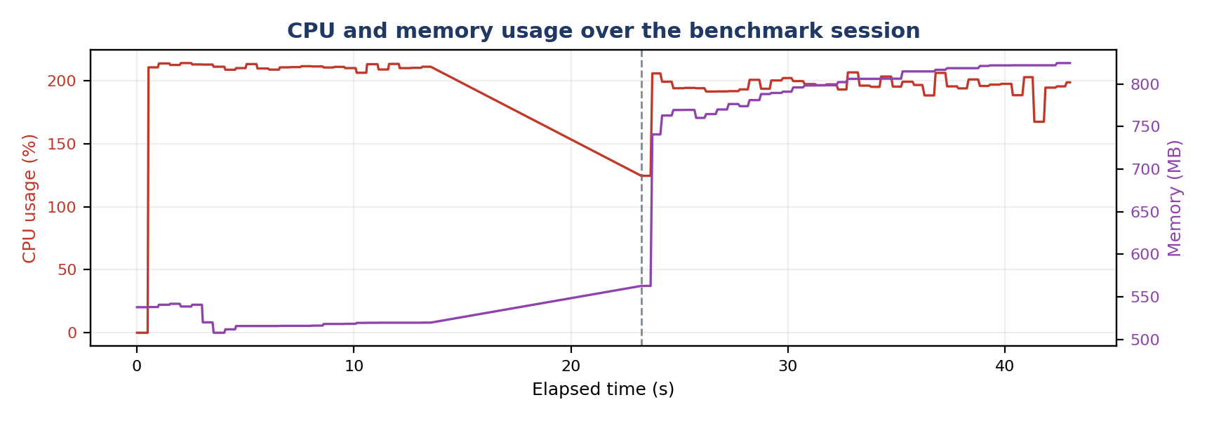
Figure 2: CPU% (red, left axis) and resident memory in MB (purple, right axis).

Where Frame Time Goes
Breaking total frame time into its three stages shows inference dominates in the light scene, but overhead (annotation drawing, JPEG encoding, per-object label text) becomes comparably large once object count rises — confirming that further optimization should target the drawing/encoding path for dense scenes, not the model itself.
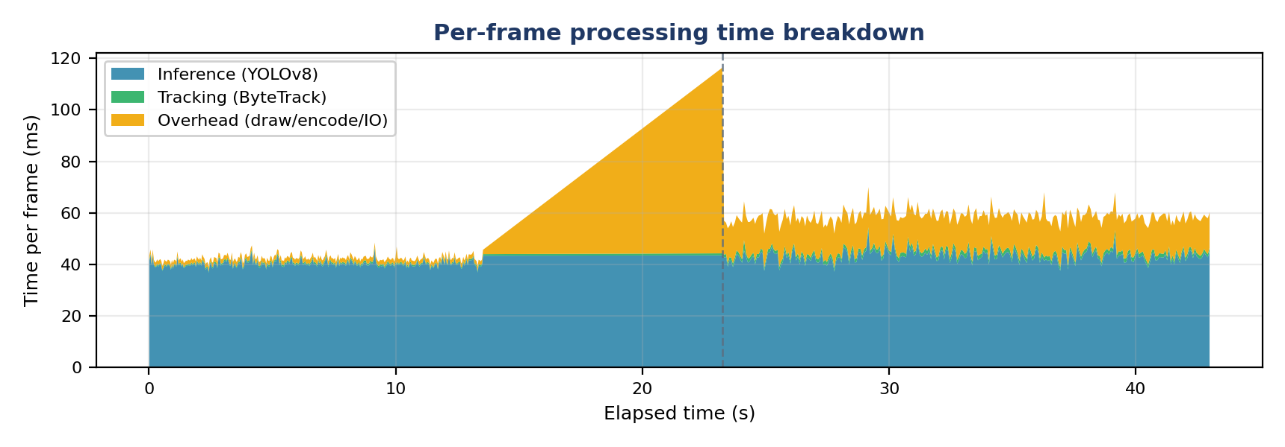
Figure 3: Stacked per-frame time — inference (blue), tracking (green), overhead (amber).
Scene Load vs. Throughput
Overlaying active object count on FPS makes the relationship explicit: FPS falls as active objects rise, and recovers as the count drops back down — the pipeline is scene-load-bound in dense conditions, not source/decode-bound.
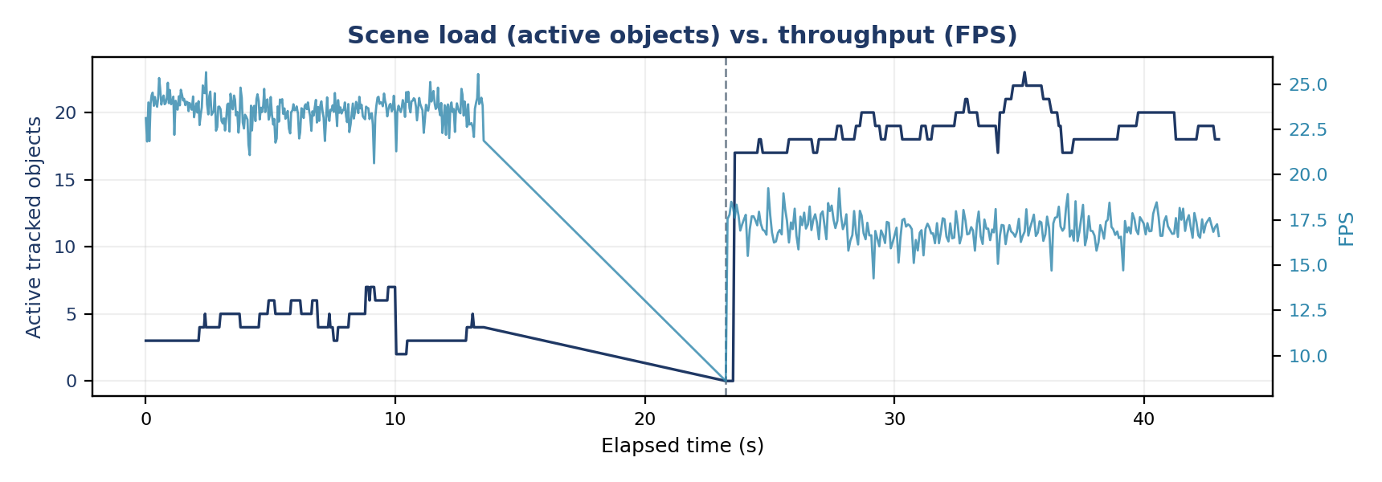
Figure 4: Active tracked objects (navy, left axis) vs. FPS (blue, right axis).

Detailed Metrics
Metric | Seg. | Mean | Median | Min | Max | P95
FPS | Light | 23.59 | 23.67 | 20.63 | 25.66 | 24.58
 | Dense | 17.05 | 17.05 | 8.6 | 19.25 | 18.23
 | Full | 20.51 | 22.31 | 8.6 | 25.66 | 24.37
Inference time (ms) | Light | 40.16 | 40.0 | 36.81 | 46.01 | 42.47
 | Dense | 43.2 | 43.09 | 37.18 | 53.03 | 46.81
 | Full | 41.6 | 40.92 | 36.81 | 53.03 | 45.67
Tracking time (ms) | Light | 0.58 | 0.58 | 0.4 | 0.83 | 0.72
 | Dense | 1.45 | 1.42 | 0.78 | 3.97 | 1.73
 | Full | 0.99 | 0.71 | 0.4 | 3.97 | 1.65
Overhead (ms) | Light | 1.69 | 1.66 | 1.5 | 6.75 | 1.81
 | Dense | 14.22 | 13.89 | 12.12 | 72.03 | 15.03
 | Full | 7.59 | 1.81 | 1.5 | 72.03 | 14.65
Total frame time (ms) | Light | 42.44 | 42.25 | 38.98 | 48.48 | 44.83
 | Dense | 58.87 | 58.66 | 51.94 | 116.34 | 63.02
 | Full | 50.18 | 44.81 | 38.98 | 116.34 | 61.39
CPU usage (%) | Light | 211.14 | 211.1 | 206.4 | 214.1 | 213.8
 | Dense | 194.24 | 195.9 | 124.6 | 206.7 | 206.3
 | Full | 203.18 | 208.8 | 124.6 | 214.1 | 213.4
Memory (MB) | Light | 521.57 | 518.4 | 507.9 | 541.9 | 540.8
 | Dense | 792.81 | 806.1 | 562.9 | 824.6 | 822.0
 | Full | 649.36 | 540.8 | 507.9 | 824.6 | 822.0
Active objects | Light | 4.21 | 4.0 | 2.0 | 7.0 | 6.0
 | Dense | 18.45 | 19.0 | 0.0 | 23.0 | 22.0
 | Full | 10.92 | 6.0 | 0.0 | 23.0 | 20.0

Light = first source (0–23.2s, low vehicle count). Dense = second source (23.2–43.0s, high vehicle count). Full = entire session combined.
Tracking Accuracy
No manually-annotated ground truth was available for this session, so standard tracking metrics (MOTA / IDF1 / identity-switch rate) could not be computed directly. In their place, the logger's own counters give a consistency check on tracking quality:
Indicator | Light scene | Dense scene
Vehicles entered (new IDs created) | 19 | 37
Vehicles exited (IDs dropped) | 14 | 17
Total unique IDs | 19 | 37
Active at segment end | 4 | 18
Avg. detection confidence | 0.809 | 0.611

Sanity check: unique IDs minus exited IDs should approximate the active-object count at session end. Light scene: 19 − 14 = 5 vs. an observed 4 active — a difference of 1, within the tracker's lost-track buffer tolerance. Dense scene: 37 − 17 = 20 vs. an observed 18 active — also consistent. No runaway ID inflation (IDs growing far faster than the scene's actual vehicle count) was observed in either segment, which is a good sign against excessive ID-switching, though it is not a substitute for measured IDF1.
Average detection confidence dropped from 0.81 (light scene) to 0.61 (dense scene). This is expected — more vehicles means more partial occlusion and smaller/further boxes — but it's close to the tracker's activation threshold (0.30) plus the base detection confidence floor (0.10), so it's worth spot-checking the dense-scene footage for missed or flickering IDs.
Findings & Recommendations
Bottleneck is scene-dependent, not model-dependent
Inference time is flat (~40–43 ms) regardless of object count; overhead (drawing + JPEG encoding) is what balloons in dense scenes (1.7 ms → 14.2 ms avg, spiking to 72 ms). If higher FPS is needed under load, optimize the annotation/encoding path first — e.g. lower JPEG quality further, skip trace/heatmap drawing when object count is high, or throttle label text rendering — before considering a smaller/faster model.
CPU-bound at ~2 cores
Sustained 190–214% CPU indicates the process is fully using roughly two cores with no headroom. A GPU-accelerated inference path (or a lighter model variant) would be the more reliable route to higher sustained FPS than further CPU optimization alone.
Memory growth warrants a longer-run check
RSS grew 286 MB over just 43 seconds. The step-pattern (rather than smooth climb) suggests it's tied to loading a new source rather than a per-frame leak, but this session was too short to be conclusive — a 10–15 minute continuous run with memory sampled throughout would confirm whether it plateaus or keeps climbing.
Tracking looks stable but is unverified against ground truth
ID/entered/exited counters are internally consistent in both segments. For a rigorous accuracy number (MOTA/IDF1) for the report, a short (~10s) manually-annotated clip run through motmetrics would close this gap.

